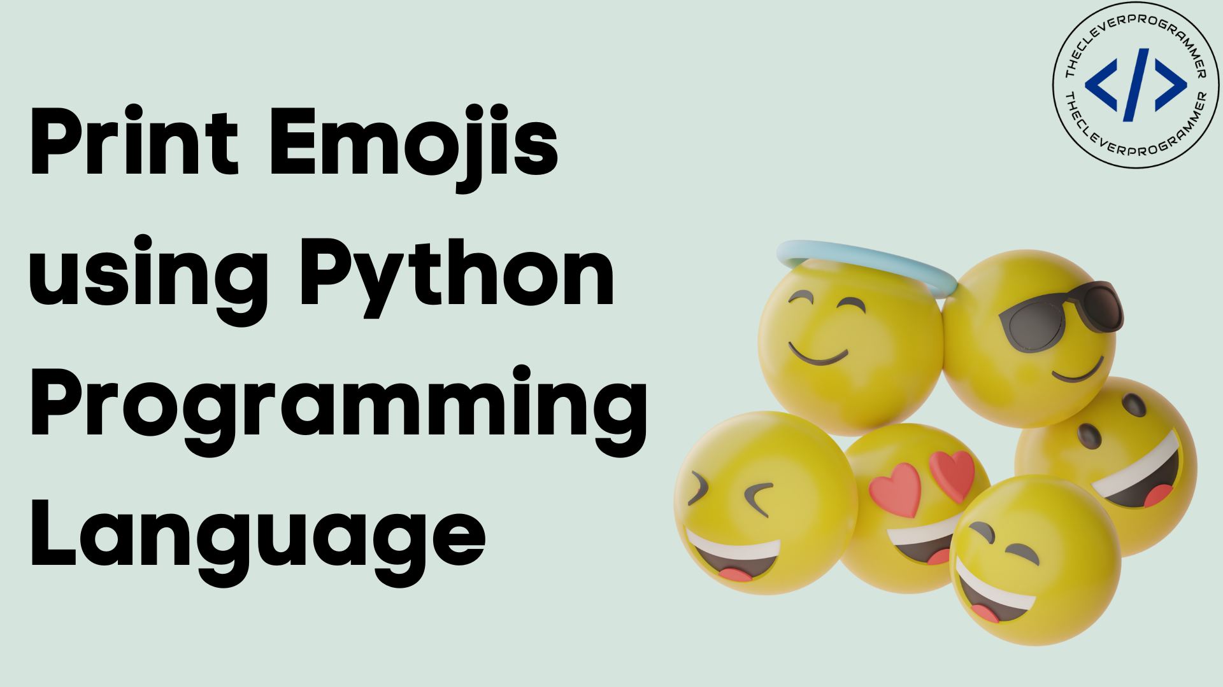

Contents:
Introduction
SystemExisting
Proposed System
Software Requirements
Hardware Requirements
Architectural diagram
Data flow diagram
Table Design
Data Dictionary
Relational diagram
Program design
Testing
Conclusion
References
Source code
Screen shot

Introduction:
Emojis are small digital images or icons used to express emotions, ideas, or actions. They are widely used in text messaging, social media, and other online communication.
This project will use Python to create your own custom emojis. You will learn how to:
- Design your own emojis
- Create a Python program to generate the emojis
- Save the emojis in a format that can be used in text messaging and other applications
Existing System:
There are many existing systems for creating emojis. Some of the most popular include:
- Emoji Maker: This online tool allows you to create custom emojis by combining different features.
- Moji Maker: This app for iOS and Android allows you to create custom emojis by drawing your own characters.
- Zmoji: This app for iOS and Android allows you to create custom emojis by mixing and matching premade features.
Proposed System:
The proposed system for creating your own emojis will use Python. Python is a powerful programming language that is well-suited for this task. It is easy to learn and use, and it has a large library of libraries that can be used to create graphics and images.
The system will consist of the following components:
- A Python program that will generate the emojis
- A database to store the emojis
- A web application that will allow users to create and manage their own emojis
Software Requirements:

=>8GB Ram
=>256 internal memory
=>intel processor

Hardware Requirements:

=>window os
=>Python Gui or Anaconda navigator(Anaconda jupyter)

Architectural diagram:
The following architectural diagram shows the components of the proposed system:

[Database] +--[Emojis]
[Web Application] +--[Create Emoji] +--[Manage Emoji]

Data flow diagram:
The following data flow diagram shows the flow of data through the proposed system:

Users -> [Web Application] -> [Python Program] -> [Database]

Table Design:
The following table shows the design of the database tables:

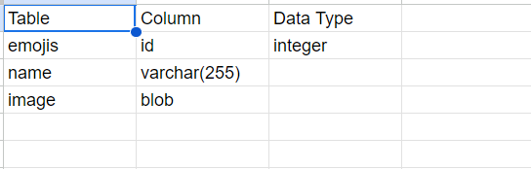

Data Dictionary:
The following data dictionary provides a description of the data in the database tables:

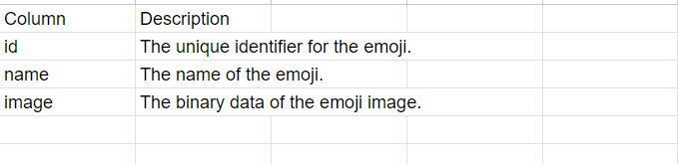
Relational Diagram:
The following relational diagram shows the relationships between the database tables:
emojis
Id
Name
Image
Program Design:
The Python program will be designed to generate emojis based on the following steps:
- Read the user's input.
- Generate the emoji image.
- Save the emoji image to the database.
Testing:
The system will be tested using the following methods:
- Unit testing: The Python program will be unit tested to ensure that it functions correctly.
- Integration testing: The Python program will be integrated with the database and web application to ensure that they work together correctly.
- User acceptance testing: The system will be tested by users to ensure that it meets their needs.
Conclusion:

This project will provide you with the skills and knowledge to create your own custom emojis using Python. The system is designed to be easy to use and scalable. It can be used to create a wide variety of emojis, and it can be integrated with other applications.

Reference:
=>From the above project we can create our own emojis
=>By these we create different emojis based on the requirements
=>These code can be used by different websites and some other platforms for creating the emojis
